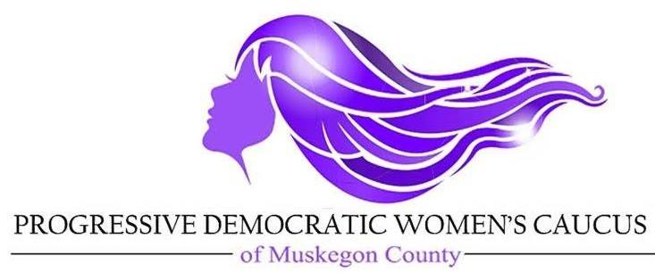

August 24, 2019
Dear Candidate,
Congratulations on your decision to run for office. In order to receive an endorsement from PDWC for the November 5, 2019 election, we must receive a completed survey and then it must be approved by our Screening and Endorsement Committee. We will need your survey no later than Friday September 5, 2019 either online (preferred) on our website (PDWC-PAC.com) or by mail (downloaded, printed and filled out) to P.O. Box 1061, Muskegon, MI 49443.
Our final decisions will be made after approval by the PDWC Board in mid September, 2018. Sometimes we endorse only and other times we endorse and donate as well.
We look forward to hearing from you. Feel free to contact one of us if you have any questions.
Sincerely,
Deb Griffin Marcia Hovey-Wright
PDWC Chair Screening and Endorsement chair
231 215 2745 231 740 8492

Our Mission: The purpose of the Progressive Democratic Women’s Caucus is to engage Progressive Democratic Women in the political process by educating, mentoring, networking, recruiting, endorsing, fundraising and advocating for issues. We share the values of equality of women common wealth for the common good and progressive democratic social and political values.

